1
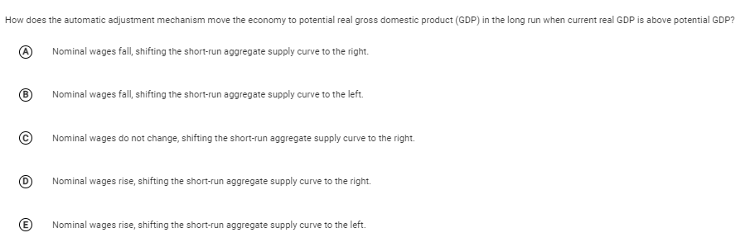

2
Assume that the marginal propensity to consume is 0.8. If the government increases its purchases of goods and services by $200 and exports decline by $50, at most the equilibrium level of income will
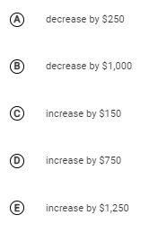

3
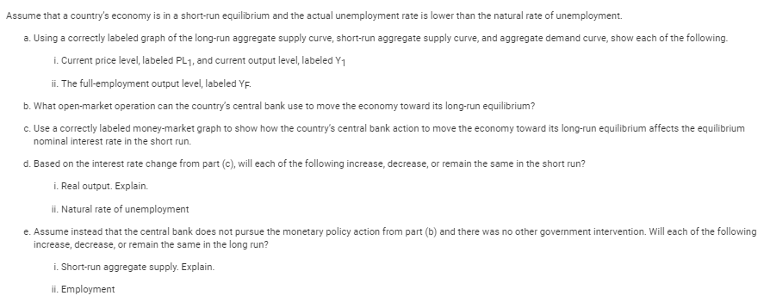

4
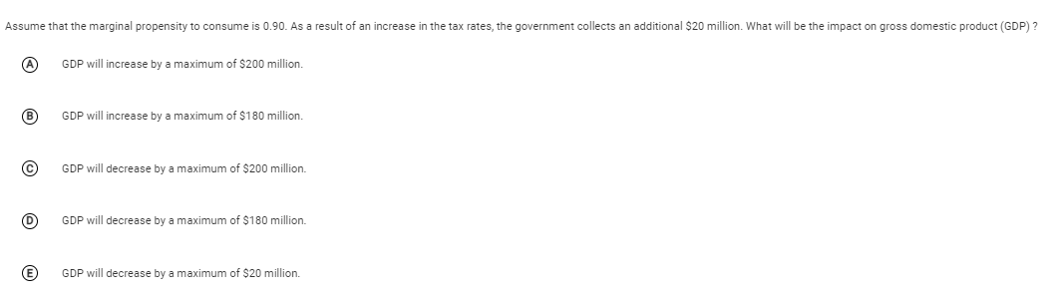

5
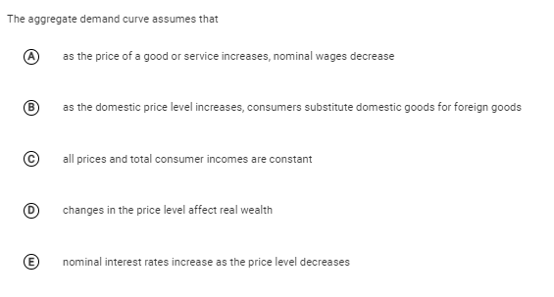

6
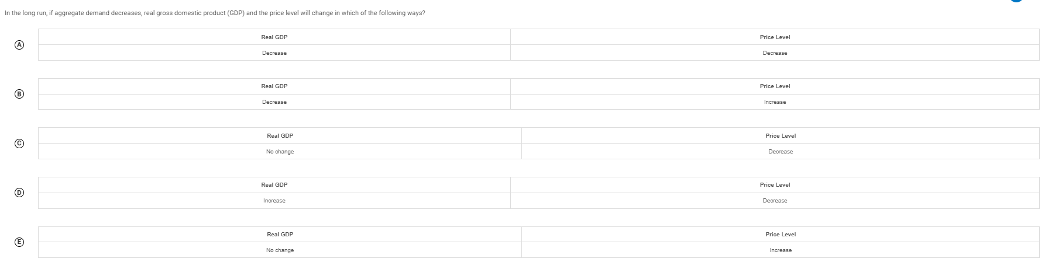

7
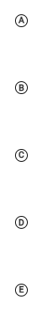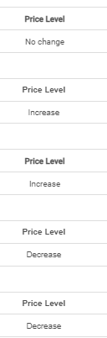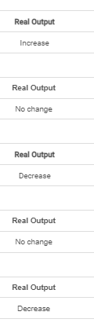

8
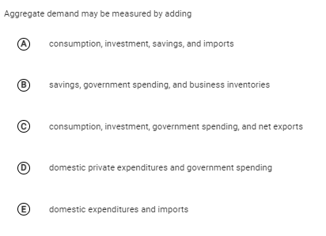

9
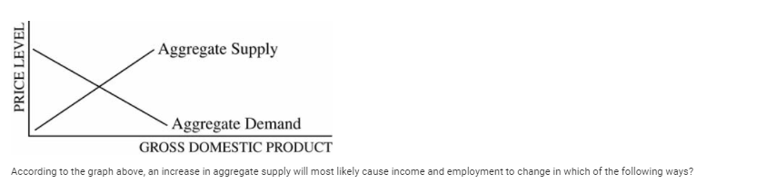
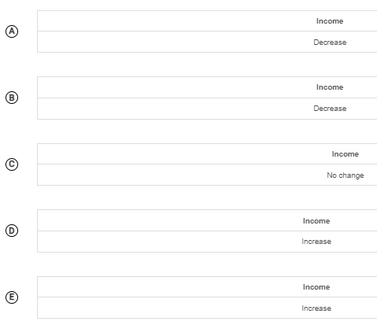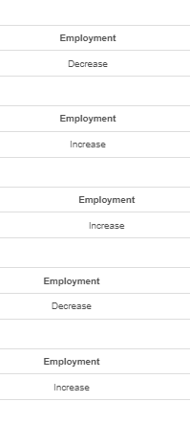

10
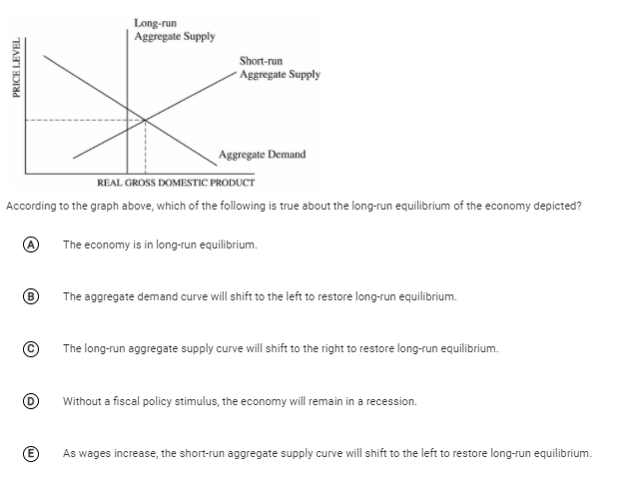

11
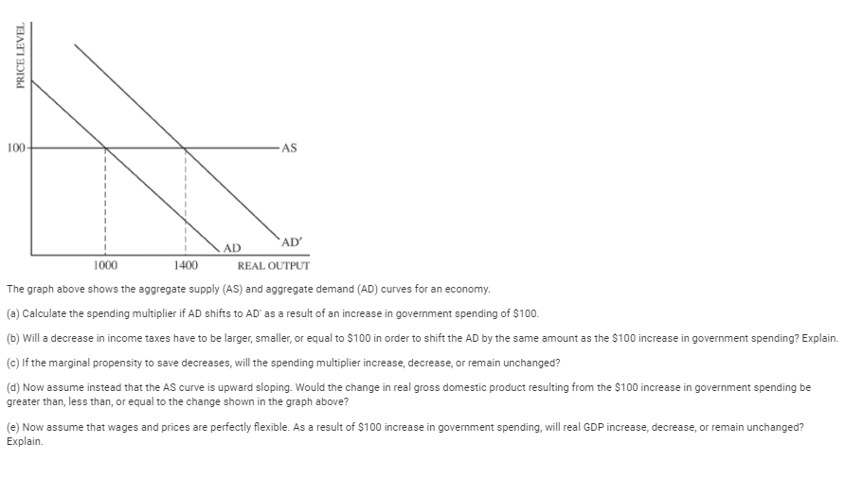

12
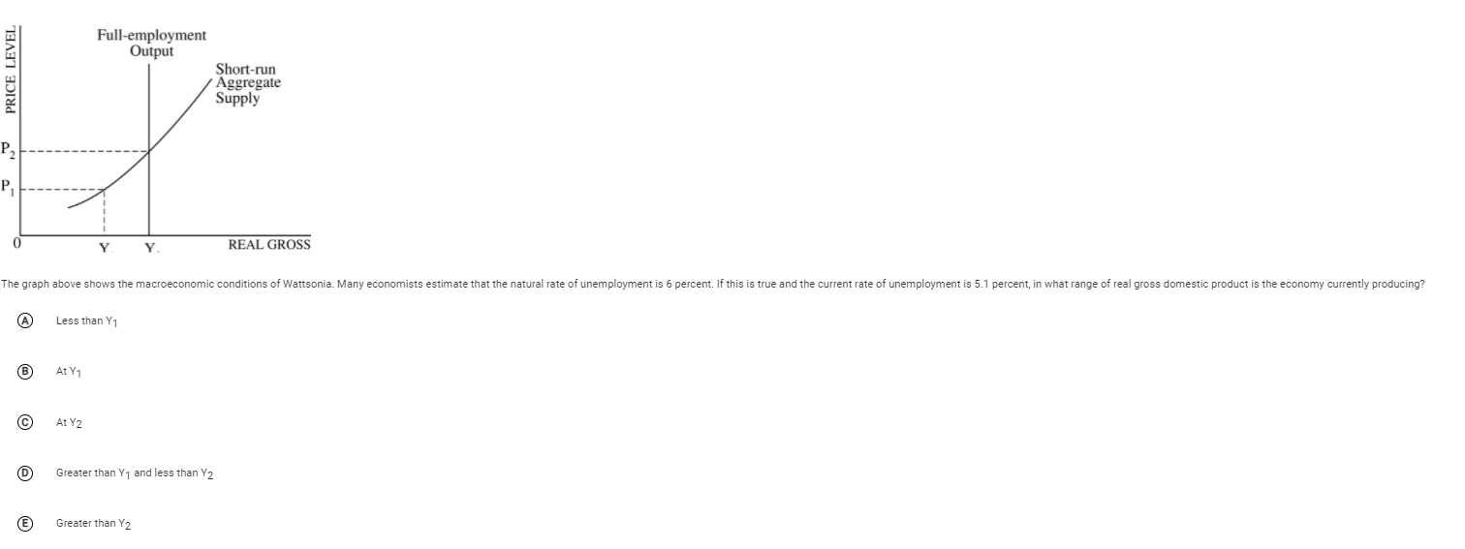

13
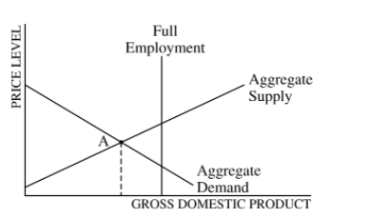
The economy of a country is currently in equilibrium at point A in the diagram above. If the government does nothing and wages are flexible, which of the following will most likely occur in the long run?
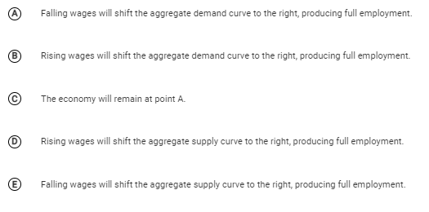

14
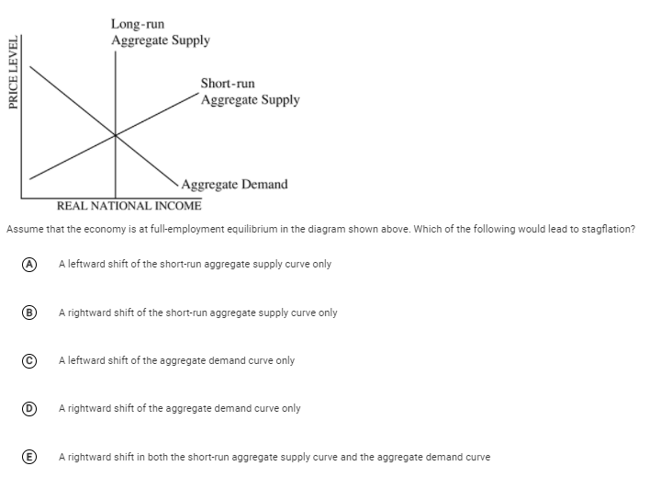

15
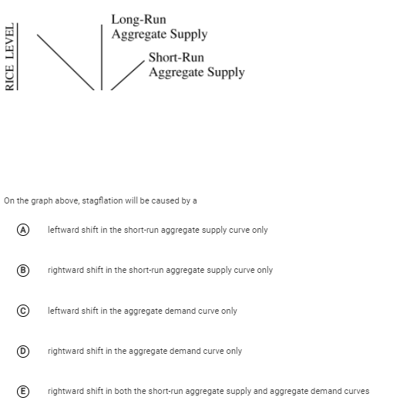

16
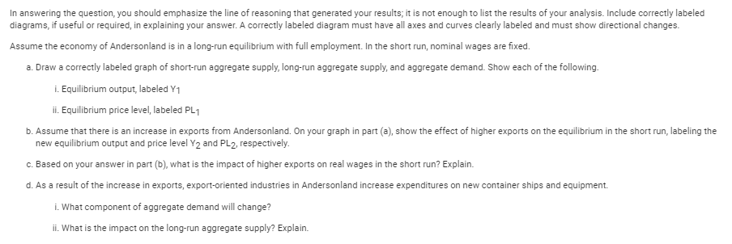

17
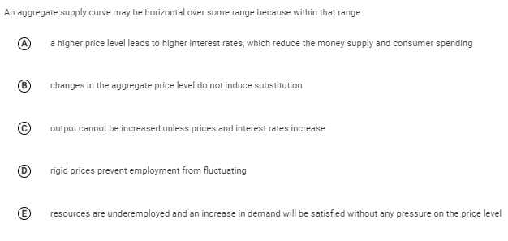

18
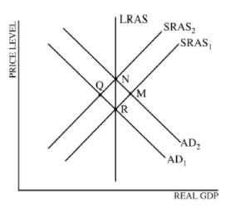
According to the graph above and starting with equilibrium point R, which of the following shifts identifies the short-run and the long-run impact of a demand-pull inflation?
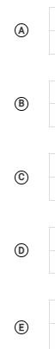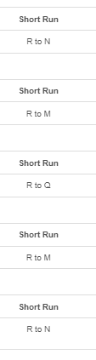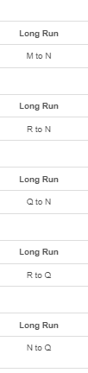

19
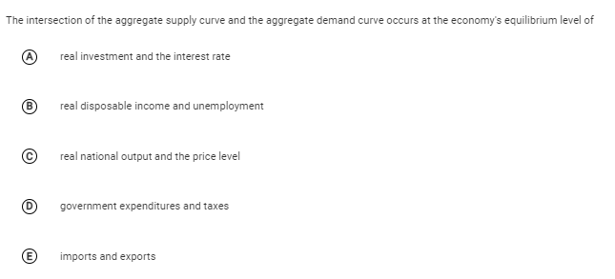

20
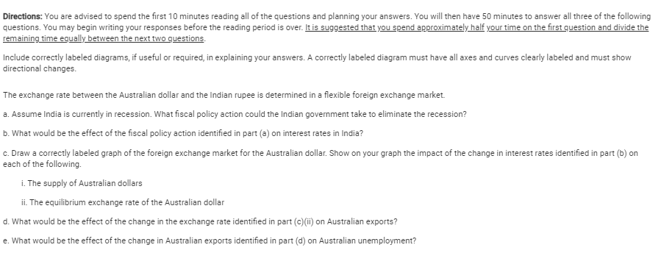

21
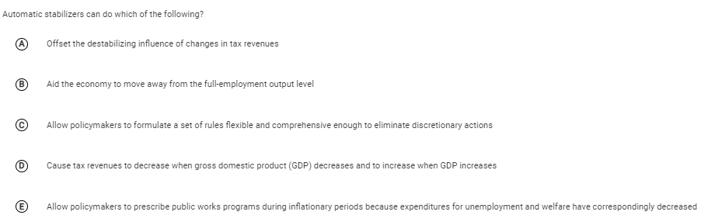

22
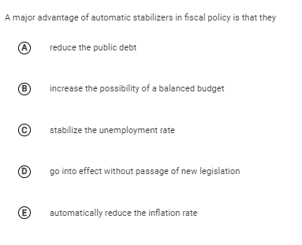

23
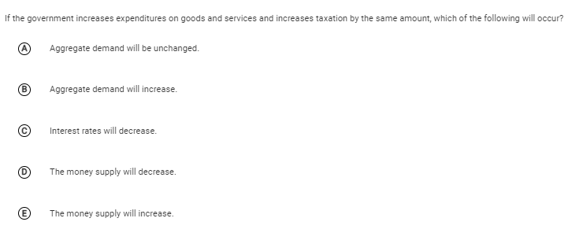

24
Faced with a large federal budget deficit, the government decides to decrease expenditures and tax revenues by the same amount. This action will affect output and interest rates in which of the following ways?
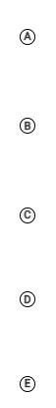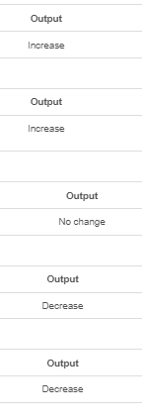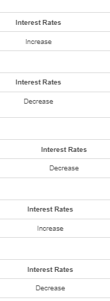

25
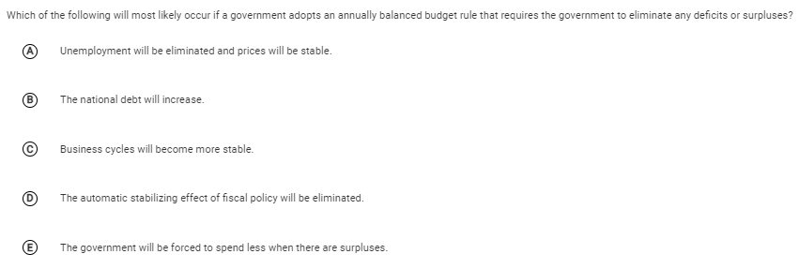

26
Assume that the marginal propensity to consume out of disposable income is 0.8 and that the government taxes all income at a constant rate of 30 percent. If gross income increases by $100, consumption will initially increase by
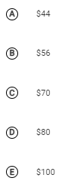

27
Assume that Jane’s marginal propensity to consume equals 0.8, and that in 2004 Jane spent $36,000 from her disposable income of $40,000. If her disposable income in 2005 increased to $50,000, her consumption spending increased by
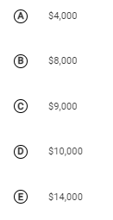

28
Suppose that in an economy with lump-sum taxes and no international trade, autonomous investment spending increases by $2 million. If the marginal propensity to consume is 0.75, equilibrium gross domestic product will change by a maximum of
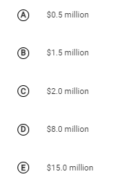

29
If the marginal propensity to consume is 0.75, then a $100 increase in investment will result in a maximum increase in equilibrium real gross domestic product of
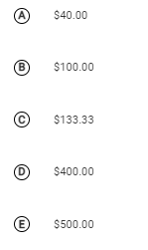

30
Suppose that the economy is in the midst of a recession and government policy makers want to increase aggregate demand by $600 billion. If the economy’s marginal propensity to consume is 0.75 and there is no crowding out, the government should do which of the following?
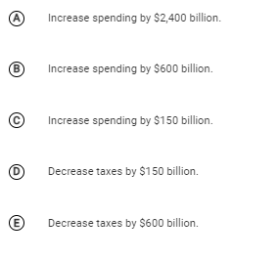

31
Suppose that autonomous consumption is $400 and that the marginal propensity to consume is 0.8. If disposable income increases by $1,200, consumption spending will increase by
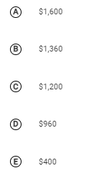

32
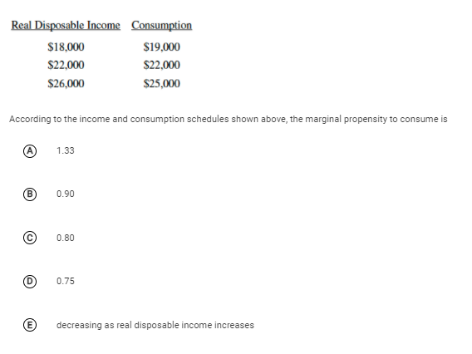

33
Include correctly labeled diagrams, if useful or required, in explaining your answers. A correctly labeled diagram must have all axes and curves clearly labeled and must show directional changes. If the question prompts you to "Calculate," you must show how you arrived at your final answer.

Canada is an open economy that is currently in a recessionary output gap.
(a) Draw a correctly labeled graph of the long-run aggregate supply, short-run aggregate supply, and aggregate demand curves, and show each of the following.
(i) The current equilibrium real output and price level, labeled as Y1Y1 and PL1PL1, respectively
(ii) Full-employment output, labeled YfYf
(b) The central bank and the government do not take any policy actions to close the output gap.
(i) Explain how the economy will adjust to full employment in the long run.
(ii) On your graph in part (a), show how the economy adjusts to full employment in the long run.
(c) Suppose the Canadian government is unwilling to wait for the long-run adjustment process. The marginal propensity to consume is 0.8. The equilibrium real output is $500 billion and the full-employment output is $540 billion.
(i) Calculate the minimum change and indicate the direction of change in government spending required to shift the aggregate demand curve by the amount of the output gap.
(ii) Calculate the minimum change and indicate the direction of change in taxes required to shift the aggregate demand curve by the amount of the output gap.
(d) Assume instead that the Canadian central bank takes actions to restore the economy to full-employment output by influencing investment spending. Draw a correctly labeled graph of the money market, and show the effect of the actions taken by the central bank on the equilibrium interest rate.
(e) Canada and Mexico are trading partners. Draw a correctly labeled graph of the foreign exchange market of the Canadian dollar, and show the effect of the change in the interest rate in part (d) on the value of the Canadian dollar with respect to the Mexican peso.

34
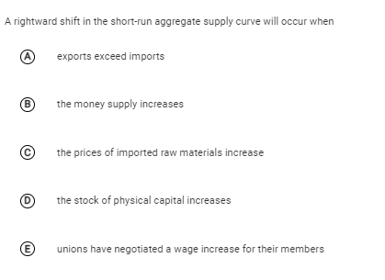

35
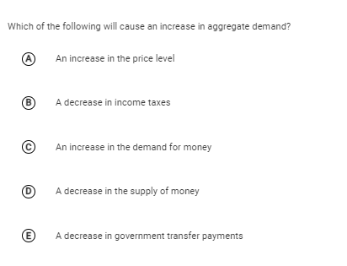

36
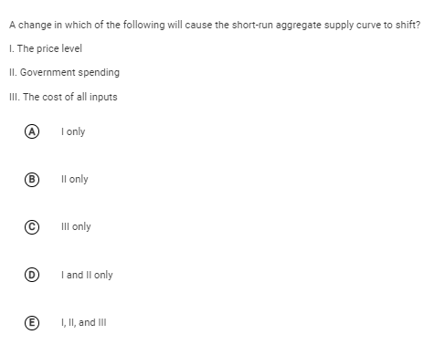

37
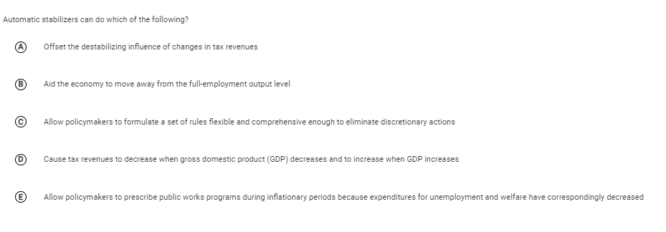

38
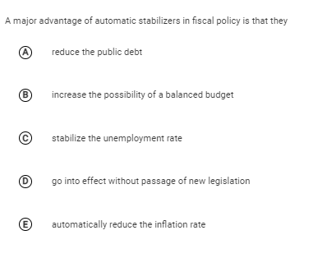

39
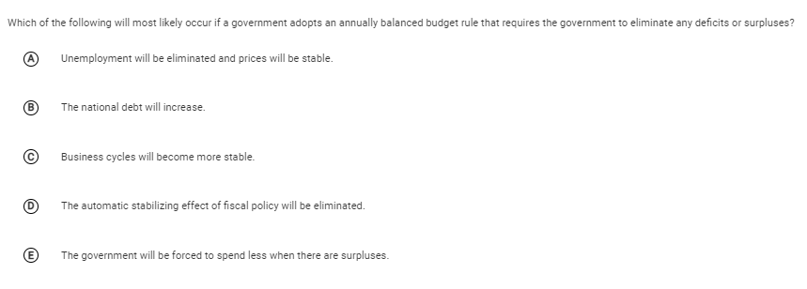

40
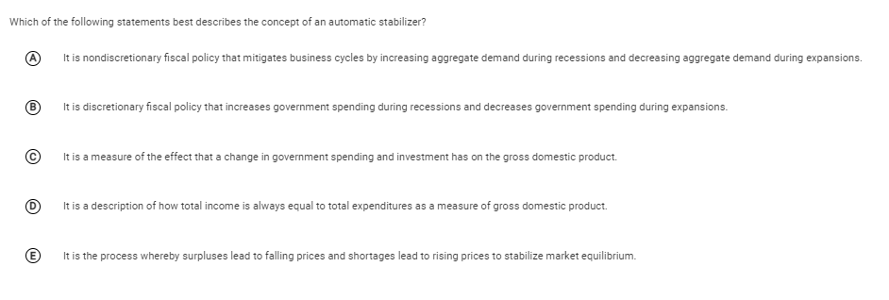

41
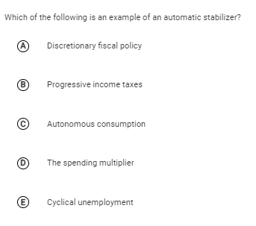

42
In answering the question, you should emphasize the line of reasoning that generated your results; it is not enough to list the results of your analysis. Include correctly labeled diagrams, if useful or required, in explaining your answers. A correctly labeled diagram must have all axes and curves clearly labeled and must show directional changes.
Assume that the economy of Meekland is in a long-run equilibrium with a balanced government budget.
- Using a correctly labeled graph of aggregate supply and aggregate demand, show each of the following.
  - Long-run aggregate supply
  - The output level, labeled Y_{E}, and the price level, labeled PL_{E}
- Assume consumer confidence falls. Show on your graph in part (a) the short-run impact of the change in consumer confidence and label the new equilibrium price level and output Y₁ and PL₁, respectively.
- Using a correctly labeled graph of the short-run and long-run Phillips curves, show the effect of the fall in consumer confidence on inflation. Label the initial long-run equilibrium point A and the new short-run equilibrium point B.
- If the government and the central bank do not pursue any discretionary policy change, how does the fall in consumer confidence affect government transfer payments in Meekland? Explain.
- Draw a correctly labeled graph of the loanable funds market in Meekland and show the effect of the change in government transfer payments you identified in part (d) on the real interest rate.
- In the absence of any changes in fiscal and monetary policies, in the long run will the short-run aggregate supply curve shift to the left, shift to the right, or remain unchanged as a result of the fall in consumer confidence? Explain.

43
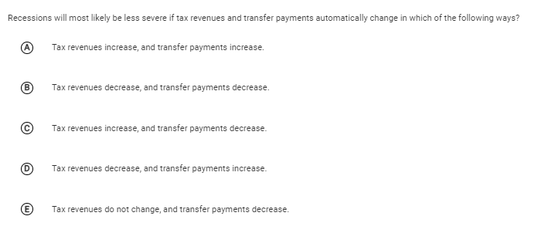

Answers

1 E
E

2 D
D

3
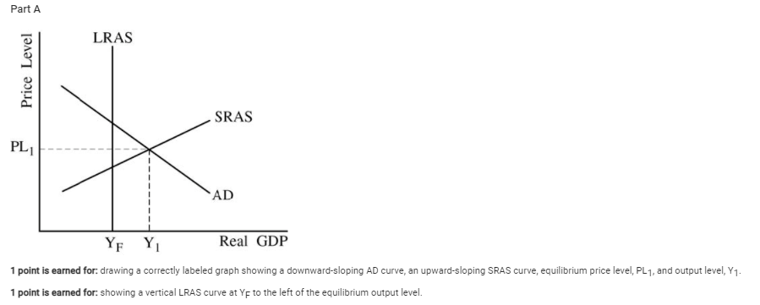

Part B
1 point is earned for: stating that the central bank can sell bonds.
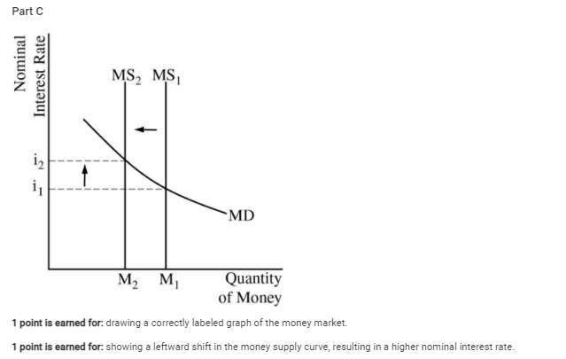

Part D
1 point is earned for: stating that real output will decrease and for explaining that interest-sensitive spending will decrease, resulting in a decrease in aggregate demand and real output.
1 point is earned for: stating that the natural rate of unemployment will remain unchanged.

Part E
1 point is earned for: stating that the short-run aggregate supply (SRAS) curve will shift to the left in the long run and for explaining that nominal wages will increase.
1 point is earned for: stating that employment will decrease.

4 D

5 D

6 C

7 E

8 C

9 E

10 E

11
One point is earned for calculating the spending multiplier: M=∆GDP/∆G) = (400/100) = 4

One point is earned for stating that a larger decrease in income taxes will be needed because part of the increase in disposable income will be saved.

One point is earned for stating that the spending multiplier will increase.

One point is earned for stating that the change in real gross domestic product would be smaller.
2 points
- One point is earned for stating that real GDP remains unchanged.
- One point is earned for explaining that input prices adjust to the long-run equilibrium immediately.

12 E

13 E

14 A

15 A

16
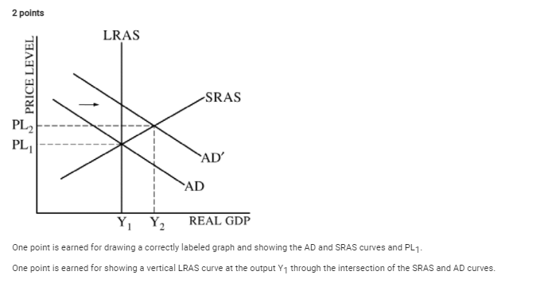
One point is earned for showing a rightward shift of the aggregate demand curve and showing Y₂ and PL₂.

One point is earned for stating that real wages will fall because the price level has increased and the nominal wages are fixed in the short run.

One point is earned for stating that the investment component of AD will change.
One point is earned for stating that the long-run aggregate supply curve will shift to the right because the capital stock has increased.

17 E

18 B

19 C

20
· One point is earned for stating that the government should either increase its expenditures (or purchases) or decrease taxes.
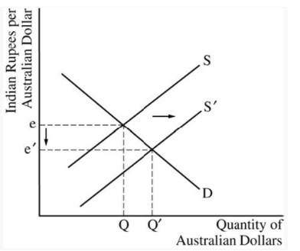

Part C
- One point is earned for drawing a correctly labeled graph of the foreign exchange market of the Australian dollar.
- One point is earned for showing a rightward shift in the supply curve for Australian dollars and a depreciation in the Australian dollar.

art D
One point is earned for stating that Australian exports will increase.

Part E
One point is earned for stating that Australian unemployment decreases.

21 D

22 D

23 B

24 E

25 D

26 B

27 B

28 D

29 D

30 C

31 D

32 D

33
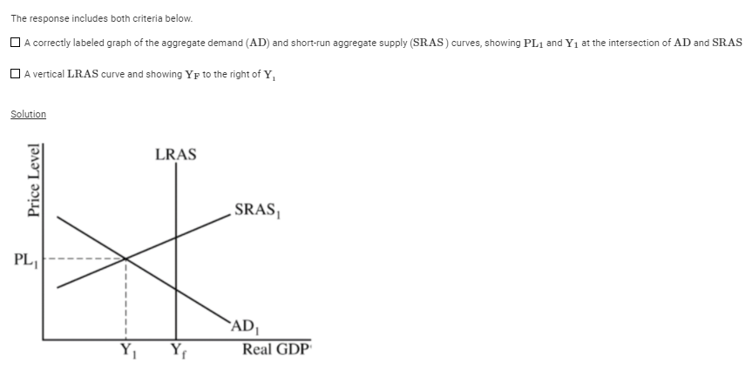
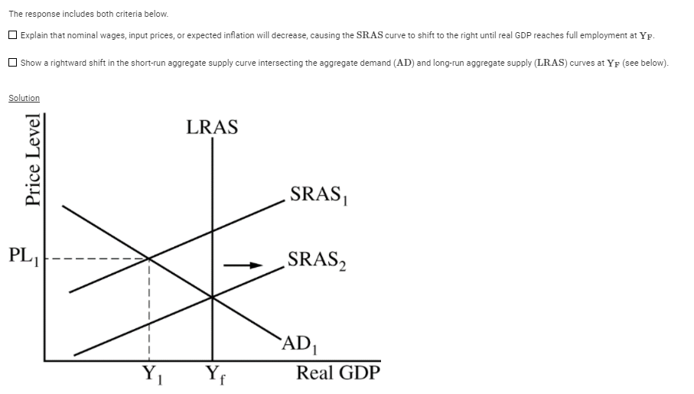
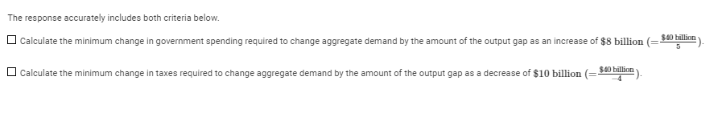
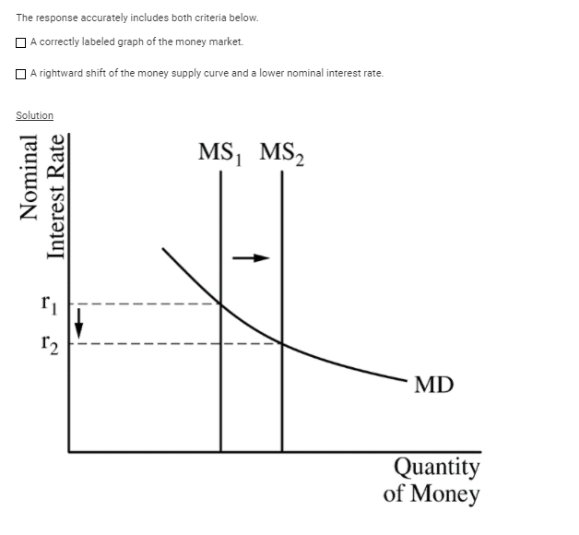
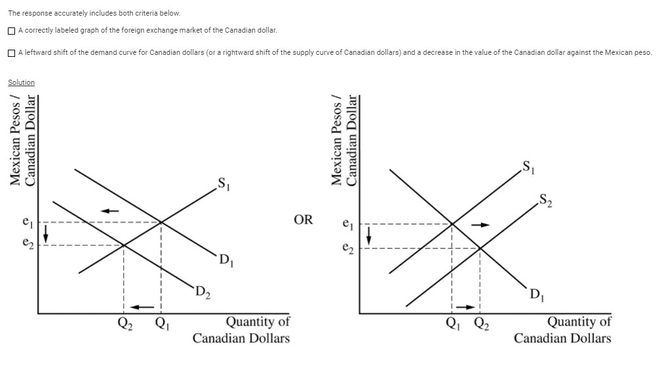

34 D

35 B

36 C

37 D

38 D

39 D

40 A

41 B

42
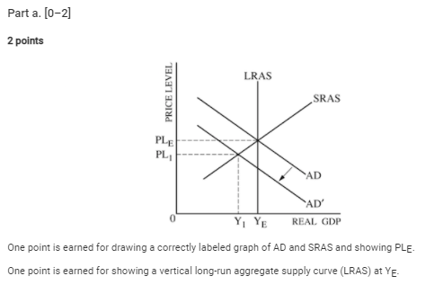
1 point
One point is earned for showing a leftward shift of the AD curve and showing the new equilibrium price level, PL₁, and output, Y₁.

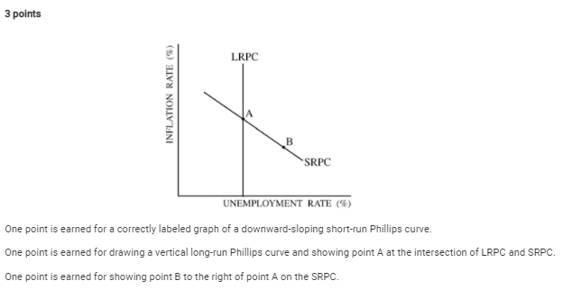
1 point
One point is earned for stating that transfer payments will increase because more people will apply for government benefits.

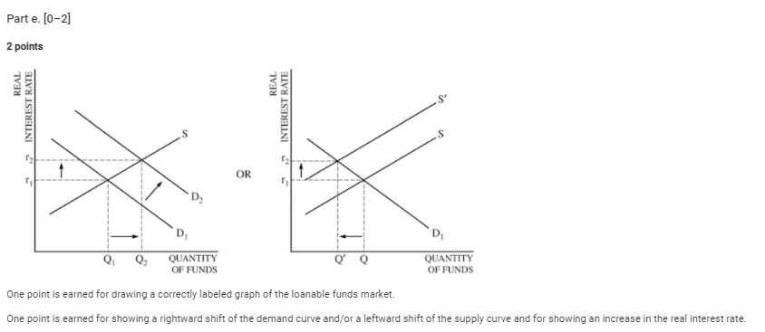

1 point
One point is earned for stating that the short-run aggregate supply curve will shift to the right because wages and other input costs will fall.

43 D

